**Improving Governance and Innovation of BUMDes Business in Wukirsari Village: Challenges and Future Opportunities**

Rohman Nur Arif 1, Guruh Ghifar Zalzalah2*, Ari Retno Purwanti3, Fikri Farhan4, Inayat Hanum Indriati5, Anandita Zulia Putri6, Fritz Jason G Monsale7

1,2,4,5 Department of Management, Faculty of Business and Law, Universitas PGRI Yogyakarta, Indonesia

3 Business Law Department, Faculty of Business and Law, Universitas PGRI Yogyakarta, Indonesia

6 Accounting Department, Faculty of Business and Law, Universitas PGRI Yogyakarta, Indonesia

7 Iloilo Science Technology University

* Corresponding Author: [guruh@upy.ac.id](mailto:guruh@upy.ac.id)

***Abstract****.*

*This article discusses the challenges and opportunities in improving governance and innovation of Village-Owned Enterprises (BUMDes) in Wukirsari Village, Imogiri District, Bantul Regency, Special Region of Yogyakarta. This activity was carried out through the International Community Service program involving students from various countries and using a participatory approach. The methods used included field observation, semi-structured interviews, and Focus Group Discussions (FGD) with BUMDes managers, community leaders, and local business actors. The results of the activity showed that the involvement of the younger generation was still low, the managers' weak understanding of business planning and financial records, and the lack of BUMDes business publications. However, there is great potential in developing local-based businesses such as batik and cultural tourism. The recommendations produced include financial management training, administration digitalization, and cross-generational collaboration in digital promotion. A participatory local innovation-based community strengthening model is proposed as a replication framework for other villages to encourage economic independence and sustainable development.*

***Keywords:*** *BUMDes, Governance, Innovation,Community Empowerment, Wukirsari, participatory.*

# INTRODUCTION

# Rural areas are the central development points aimed at increasing independence in all aspects of community, nation and state life. (Wijaya 2003) According to the mandate of Village Law No. 6 of 2014, rural development can be achieved through the protection and strengthening of democratic village communities. Rural development is to place the village as a means of development, so that the goal of reducing various disparities can be realized. Budiono (2015) explains that there is a way for the village government to promote development at the village level where the village government receives the authority to manage the village independently by village-level economic institutions. One of these institutions is the Village Company (BUMDes). The utilization of natural resources related to resource-based economic activities, especially agricultural natural resources, makes business and business a leading sector in terms of community economic empowerment (Bobo, 2003).

# In an effort to improve village development, the central government through village regulations provides regional financial authority (autonomy) without intervening in the central government (Nailissa, 2020). BUMDes is expected to become a business and social institution that aims to improve the wells of village communities and collect social capital for village communities. (Permataari & Imaniar, 2022) BUMDes must be able to manage appropriate village businesses based on superior village potential. Reviving the role of BUMDes in the village socio-economic system. Contributing to village development. By encouraging entrepreneurship and innovation at the local level, BUMDes contributes to the general economic growth of rural areas in Indonesia. This economic unit not only reduces poverty and inequality, but also helps communities to control their economic destiny. With the support of government programs and initiatives, BUMDes has the potential to change the socio-economic landscape of Indonesian villages and create a more integrated and prosperous society for its people.

# However, challenges such as limited capital, human resource capacity and community participation or involvement are major obstacles in improving the community's economic wells, in village development. This remains a major focus in underdeveloped Indonesian villages. Fitriyani's (2023) research shows that the role of BUMDes in improving the village economy includes strategies to optimize management, ongoing support and collaboration with external stakeholders. Meanwhile, Kirowati and Setia's (2021) research highlights the importance of social capital such as trust and social networks for effective BUMDes management. In addition, innovation strategies play an important role in BUMDes development in increasing the possibility of wells in the local economy and village communities.

# In Wukirsari Village, the Wukirsari Village-Owned Enterprise, Imogiri District, Bantul Regency is called the Wukirsari Raya Village-Owned Enterprise, hereinafter abbreviated as "BUMDes Wukirraya". BUMDes Wukirraya is domiciled in Wukirsari Village, Imogiri District, Bantul Regency. BUMDes has great potential in developing local potential businesses, such as agriculture, crafts, and tourism. However, challenges in terms of transparent, accountable, and participatory governance are still the main focus in optimizing the role of BUMDes. So it is still far from the expectations of the Community in managing BUMDes. This BUMDes manages several businesses that originate from regional potential such as agricultural products, crafts and tourism which are then developed and managed properly, how is the role of BUMDes in creating welfare for village communities, but there are challenges in managing assets professionally, so this can be used as interesting material to study.

# In Wukirsari Village, international customer service activities are carried out, focusing on strengthening BUMDes capabilities. This program includes students from various countries who work with local communities in designing strategies to improve BUMDes business management and innovation. This approach strengthens the community's ability in independent and sustainable management. Active community participation in this service program reflects a participatory approach to village development. The community is not only an object, but also a topic for planning and implementing programs in accordance with the principles of community-based development. Tasia & Martiningsih (2023) This highlights factors such as participatory principles, the importance of transparency, accountability, and implementation of sustainability, as well as active management in developing positive leadership and BAMDes.

# Based on this background, this study aims to analyze the challenges and opportunities in improving the governance and innovation of BUMDes businesses in Wukirsari Village. This study is expected to contribute to village development in the economic empowerment, participatory and sustainable model and other village references that optimize the role of BUMDes. In addition, this study focuses on the language of strategies that can be applied by BUMDes managers to address market dynamics, limited resources and digitalization requirements.

# METHODS

# The activity was carried out in Wukirsari Village, Imogiri District, Bantul Regency, Special Region of Yogyakarta. This activity lasted for one day on May 19, 2025. The method used was a participatory approach with direct community involvement in the International Community Service event, starting from initial observations, discussions on management, to strategy formulation. It is hoped that this activity can be input for BUMDes Management. The technique used in this study was data collection including field observations, semi-structured interviews with BUMDes managers, and Focus Group Discussions with community leaders and local business actors. Activity participants were selected using purposive sampling techniques, namely parties who play a direct role in BUMDes activities, such as core administrators, BUMDes administrators, and village youth. To realize the targets of this program, the method and stages of implementation were determined, including Focus Group Discussions, counseling by means of lectures and discussions, with the following descriptions:

# Focus Group Discussion was conducted to conduct dialogue and discussion with BUMDes administrators, community leaders and activity participants related to the problems faced in managing BUMDes in Wukirsari Village. At this stage, the Director of BUMDes Wukirsari presented several village-owned business entities.

# Counseling through lectures and discussions, to provide insight into the importance of developing productive businesses as a source of BUMDes income. In addition, counseling is also carried out to compile an economic analysis of business potential and a plan for expanding the BUMDes business in Wukirsari Village. The program implementation team collaborates with resource persons who have competence in developing BUMDes owned by Wukirsari Village.

# Direct observation of several village-owned businesses to see when the activities are taking place.

# All stages of implementation were carried out directly on site, namely in Wukirsari Village. This face-to-face method was chosen so that the implementing team could understand the real field conditions, build intensive communication with the community. To support daily coordination between the implementing team and local partners, a WhatsApp group was formed involving BUMDes administrators, village officials, students, and supervising lecturers. This communication media is very helpful in conveying information, discussing technical obstacles, and carrying out quick follow-ups on matters that arise during the implementation of activities.

# RESULT AND DISCUSSION

1. **Focus Group Discussion**

At this stage, it was visited directly by the Director of BUMDes, Village Secretary, Village Youth, Village Secretary, and BUMDes Administrators and Management and the program activity implementation team. This conference was intended to determine problems related to the management of BUMDes in a participatory manner. Discussions were held openly, allowing all parties to express their opinions, experiences and solutions in relation to actual terms. One of the most important topics expressed was the lack of youth involvement, residents' interest in managing the village and publication of BUMDes efforts, especially among wider circles. Therefore, the inclusion of village youth is an important focus in supporting social media promotion.Selain masalah publikasi, Forum Group Discussion ini juga menyoroti

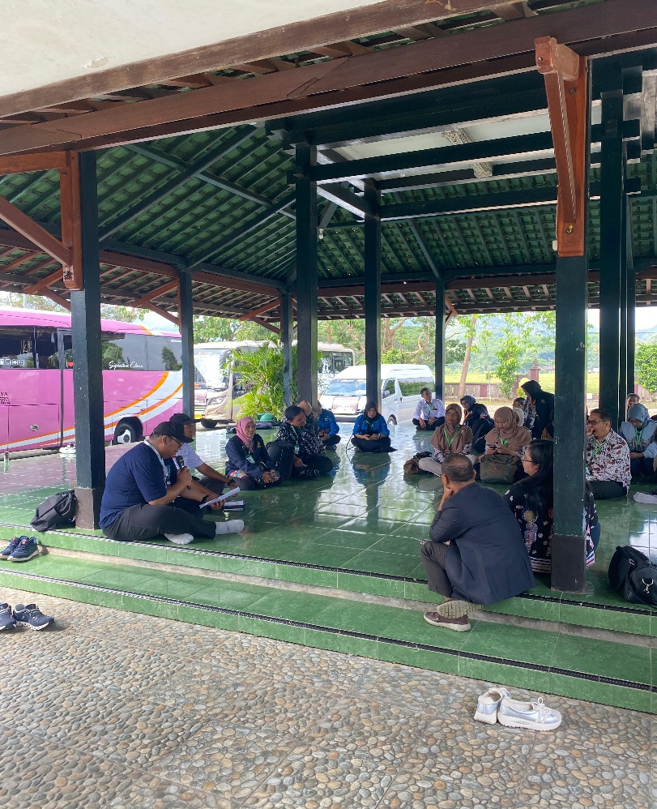Lack of understanding of BUMDes managers in financial management and preparation of their business plans. This discussion has brought several recommendations, including the need for further training for financial management and digitalization of administration. BUMDes business development is also proposed to focus more on local possibilities such as Batik and Cultural Tourism. At the discussion meeting, participants agreed on the importance of developing an integration plan to increase village income. The result of this Forum Group Discussion is the initial status of creating a strategy to strengthen institutional strengthening and sustainable development of BUMDes businesses in Wukirsari Village.

1. **Counseling through lectures and discussions**

BUMDes with operating business units can be a source of economic strength for the village and can be a major contribution to the village's original income. To recognize this, we need to develop management and leadership skills that emphasize the importance of building a sustainable, productive, and professional business. In BUMDes management, the old paradigm of watching activities as social activities must be changed only to a structured economic orientation of work systems and procedures. This concept is the focus of consultation activities that occur in the form of lectures and discussions. The materials presented include the importance of an effective company management system, business publishing strategies on social media, and effective and responsible financial records.

This suggestion also aims to increase collective awareness of the importance of innovation for village business development. All administrations and members and BUMDes administrators are invited to provide results by actively mastering the challenges of managing business units. Lectures and discussions that not only convey theory, but also provide practical touches when building entrepreneurial thinking in the BUMDes environment. Through open discussions, participants receive new insights into managing businesses professionally. As a result, BUMDes management receives a broader perspective in managing business units for sustainable and adaptive change. In addition, this activity has built a spirit of intergenerational collaboration, especially through the involvement of village youth in the development of digital advertising media. That this pattern will be the beginning of the institutional transformation of BUMDes in a more innovative and contrasting organizational orientation because of the needs 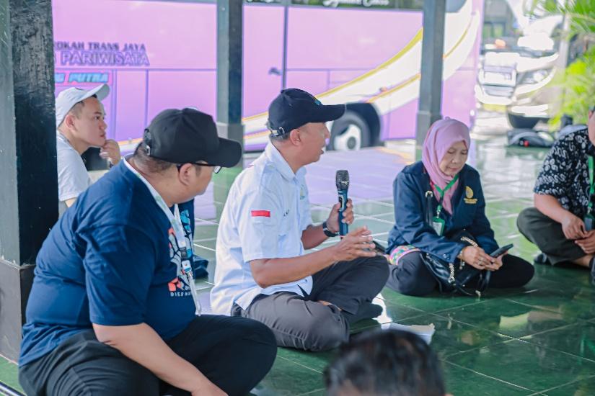of the community.

1. **Obsevation**

Observation is one way in which researchers collect data that is done through a method where they directly go into the field and get relevant information. This method allows researchers to clearly see the activities and interactions that occur at the research site. In the context of BUMDes research, observation helps to understand the dynamics of village businesses directly without intermediaries. Observation techniques require excellent analytical skills, accuracy, and sensitivity to social conditions in the field. Researchers must be able to systematically record various activities, behaviors, and obstacles exposed by BUMDes managers. In the case of observation, researchers can record contextual information that may not be revealed through interviews or documentation. Therefore, this method is an important addition to checking depth data and increasing the validity of research findings.

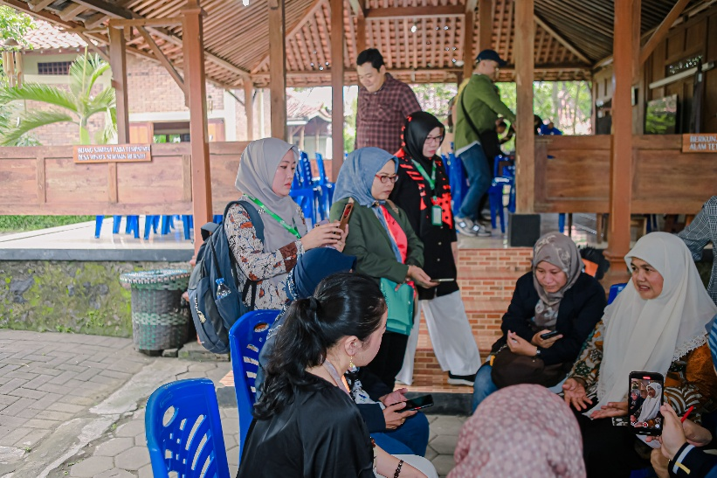

# CONCLUSION

Based on the results of the study, it can be concluded that BUMDes Wukirraya in Wukirsari Village is still less involved in BUMDes management, Village business publications and financial recording planning that is not mature enough. Therefore, this activity will encourage increased participation among local governments, especially the younger generation, in the management and publication of village businesses. In addition, this will improve the leadership skills of BUMDes management, which are related to financial records, business planning and recognition of the importance of sustainable innovation. Another advantage is the growth of cooperation between residents and increased public trust in the performance of BUMDes as a driving force for the village economy. In the future, we recommend that there be further training courses in digital and business management, which will be extended through a cross-sector partnership network. This activity also includes strengthening conceptual knowledge in the form of local empowerment innovation through a model, namely strengthening local innovation-based communities, which are managed professionally and participatory, namely strengthening local innovation-based communities. This model can be a replication framework for other villages in increasing economic and regional independence.

# ACKNOWLEDGMENTS

The author would like to thank the Regent of Bantul, the Wukirsari Village Management and the management of BUMDes Wukirraya, Universitas PGRI Yogyakarta and students and lecturers who have contributed to the implementation of this International Community Service activity so that it can be carried out well. So that the results of this activity produce articles that can be published. In addition, gratitude is also addressed to the team and University who have been willing to collaborate in the International Community Service activity.

# REFERENCES

Hidayat, S., Nurhidayatullah, D., & Zain, H. M. (2022). Perencanaan strategis dan kebijakan pengelolaan dana desa studi kasus Desa Wukirsari, Imogiri, Bantul, DIY. *JOURNAL OF GOVERNMENT (Kajian Manajemen Pemerintahan dan Otonomi Daerah)*, *7*(2), 51-68.

Agunggunanto, E. Y., Arianti, F., Kushartono, E. W., & Darwanto, D. (2016). Pengembangan desa mandiri melalui pengelolaan badan usaha milik desa (BUMDes). *Jurnal Dinamika Ekonomi dan Bisnis*, *13*(1).

Negoro, A. H. S. (2018). Inovasi BUMdes dalam pengelolaan potensi kewirausahaan masyarakat pesisir.

Pratama, T. A., Juanda, B., & Mulatsih, S. (2025). Dana Desa dan Upaya Pengentasan Kemiskinan di Kabupaten Subang. *TATALOKA*, *27*(1), 13-24.

Kirowati, D., & Setia, L. (2018). Pengembangan desa mandiri melalui BUMDes dalam meningkatkan kesejahteraan masyarakat desa (Studi kasus Desa Temboro Kecamatan Karas Kabupaten Magetan). *Jurnal AKSI (Akuntansi Dan Sistem Informasi)*, *3*(1).

Kinasih, I., Widiyahseno, B., & Dj, E. W. (2020). Badan Usaha Milik Desa (BUMDes) dalam memperkuat perekonomian masyarakat. *Jurnal Administrasi Pemerintahan Desa*, *1*(1), 33-44.

Sareng, C. E. D., Pradana, I. P. Y. B., & Kellen, P. B. (2024). KEPEMIMPINAN, SUMBER DAYA, DAN PARTISIPASI MASYARAKAT: FAKTOR DI BALIK KEBERHASILAN BUMDESA. *JURNAL TRIAS POLITIKA*, *8*(2), 161-182.

Se, H., & Langga, L. (2021). Peranan BUMDes dalam Mendukung Perekonomian dan Meningkatkan Kesejateraan Masyarakat Desa Watusipi Kecamatan Ende Kabupaten Ende. *RESONA: Jurnal Ilmiah Pengabdian Masyarakat*, *5*(1), 75-86.

Wahyuningsih, R. S. H., & Rahmawati, A. (2020). Strategi Menggerakan Perekonomian Desa Melalui Penguatan Kapasitas Usaha Bumdes Sri Taman Rejeki Judul Artikel. In *Prosiding Seminar Nasional Program Pengabdian Masyarakat*.

Haviya, O., Gowon, M., & Erwati, M. (2022). Analisis Pengelolaan Keuangan Badan Usaha Milik Desa (BUMDes) di Desa Mekar Jaya Kecamatan Bajubang. *Jambi Accounting Review (JAR)*, *3*(2), 201-212.

Khairani, L., Santoso, P., & Aktar, S. (2021). Penguatan Kapasitas Pengelola Bumdes Mozaik Dalam Pengembangan Pariwisata “Getek Online” Melalui Pemanfaatan Digital Marketing Google My Business. *JMM (Jurnal Masyarakat Mandiri)*, *5*(6), 3301-3315.